Receiving SubSystem

ERD for UX process

Place your ERD diagram here.

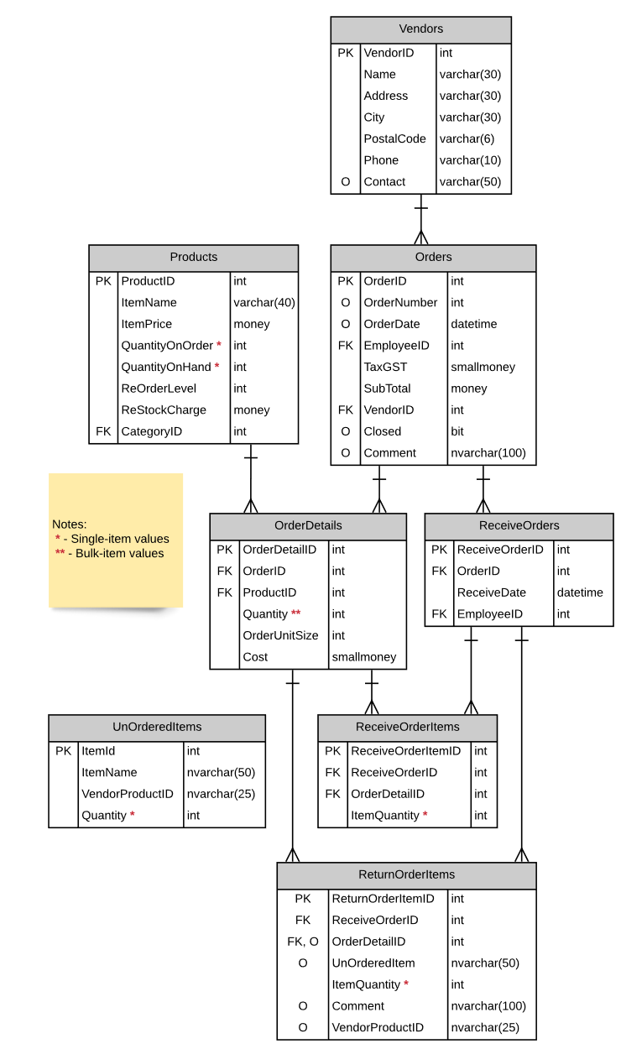

Possible UX Interface

Place your screen design(s) here
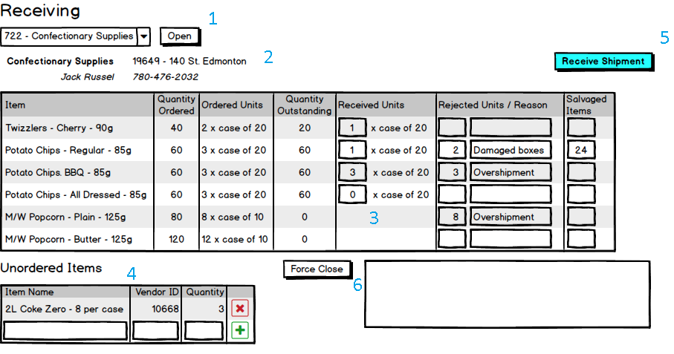
Controls |  | Events
DisplayOrderList(1) |  | OnClick()  -Validates user credentials  -Retrieves valid orders  -binds list of orders to list
BBL Class(es) and Method (s)
OrderListController | List<OrderList>DisplayOrderList(int EmployeeID)  -Order.Closed is false and values exist for OrderNumber and OrderDate for returned orders.  -Returns Order.OrderNumber and Order.Vendor.Name
SQL Table(s): (C,R,U,D) |  | ViewModels
Orders(R),Vendors (R) |  | None

DisplayVendorDetails(2)  Display_Shipment(3)  LogUnorderedItems(4) |  | OnClick  -retrieves vendor details and shipment details  - Gridview is populated after the user clicks on 'open'
BBL Class(es) and Method (s)
VendorController  ShipmentController  UnOrderedItemController | Void DisplayVendorDetails(OrderID)  -returns a list of variables Vendor.VendorID (hidden), Vendor.VendorName, Vendor.Address, Vendor.Contact, and Vendor.Phone from the selected Order  void DisplayShipment(OrderID)  -returns a list of details for a selected order that corresponds with columns in the gridview  Gridview Columns for DisplayShipment(3)  Item – Product.ItemName,  Quantity Ordered - [OrderDetails.Quantity * OrderDetails.OrderUnitSize],  Ordered Units - OrderDetails.Quantity and OrderDetails.OrderUnitSize,  Quantity Outstanding - Products.QuantityOnOrder  Receiving values (Received_Units, Reject Units/Reason, and Salvaged Items) will either be 0 or empty strings until the user modifies these values  void LogUnorderedItems(orderID)  Used to display a gridview that allows the user to log UnOrderedItems that may come with a shipment.  GridView Colums for UnorderedItems(4)  -Item name is a string( or a description) it corresponds to ItemName in the UnOrderedItems table  -ItemID is generated, and not displayed  -VendorId is a string that refers to VendorProductID in UnOrderedItems  -quantity is an int that refers to quantity in the unordered items table  --Item name, VendorID, and quantity are required before entry is added to UnOrderedItems table.  -user has the ability to add/delete entries on this table by click on the '+' or 'x' buttons.
SQL Table(s): (C,R,U,D) |  | ViewModels
Vendor(R),Orders(R),  OrderDetails(R),Products(R),  UnOrderedItems(C,R,U,D) |  | Vendors_DisplayVender  OrderDetails_DisplayShipment  UnOrderedItems_GetUnOrderedItems

ReceiveShipment(5) |  | OnClick  -validates user input in DisplayShipment(3), and  LogUnorderedItem(4)  -processes transaction if validation passes
BBL Class(es) and Method (s)
ShipmentController | Void ReceiveShipment(orderID,received_units, rejected_units, salvaged_items, unorderd_item_name, unordered_vendorID, unordered_quantity)  -Method is used validate all user input in the DisplayShipment and UnOrderedItems gridview before committing a transaction.  -Verify that Order.OrderClosed is false  -A Receive_Orders table instance will be created here.  The ReceiveOrders table  ReceiveOrderID must be generated  OrderID corresponds with the OrderID of this selected order  ReceiveDate is the current date of processing  EmployeeId is the ID of the worker logged in  Update Products table for specified order  -Add received units value and salvaged units value from the Display_Shipment(3) gridview to the QuantityOnHand field of the Product table  -Received Units cannot be zero  -Salvageditems cannot be greater than OrderDetails.OrderUnitSize  -Product.Quantity = Product.Quantity + (OrderDetails.Quantity * OrderDetails.OrderUnitSize )+ salvageditems  -Subtract received units and salvaged units from the Display_Shipment(3)  gridview from the QuantityOnOrder field of the Product table  -Received Units cannot be zero  -Salvageditems cannot be greater than OrderDetails.OrderUnitSize  -Product.QuantityOnOrder = Product.QuantityOnOrder -  (OrderDetails.Quantity * OrderDetails.OrderUnitSize ) + salvageditems  Update ReturnOrderItems for specified order  - If rejected items exist :  -A ReturnOrderItems table instance needs to be created  -ReturnOrderItemID -> PK is generated  -ReceiveOrderID -> is the generated PK for ReceiveOrders  -OrderDetailID -> is the OrderDetailID for the selected Order  -UnOrderedItem is null  -Comment is assigned the user input in the Display_Shipment(3)  GridView ("reason")  -VendorProductID -> null  -if unordered items exist :  -ReturnOrderItems table instance needs to be created  -ReturnOrderItemID -> PK is generated  -ReceiveOrderID -> is the generated PK for ReceiveOrders  -OrderDetailID -> is the OrderDetailID for the selected Order  -UnOrderedItems is UnOrderItems.ItemName  -ItemQuantity is UnOrderedItems.Quantity  -Comment is "Not an original order"  -VendorProductID is UnOrderedItems.VendorProductID  check if  OrderDetails.QuantityOnHand for all products in the order = 0  then  set Orders.Closed = "true", and Orders.Comment = "Order complete"  -commit changes  -refresh display (refresh list of active PO's for this employee)
SQL Table(s): (C,R,U,D) |  | ViewModels
ReceiveOrders(C)  Product(U)  ReturnOrderItems (C,U)  UnOrderedItems (R) |  | None

Controls |  | Events
Close_Order (6) |  | OnClick  -user must click force close button
BBL Class(es) and Method (s)
OrderController | Void Order_Close(OrderID)  -verifies that user has the credentials to close order  -verifies that a comment exists  -changes order status to 'closed'  -reduce quantity ordered by quantity outstanding on the order  -Products.OnOrder = Products.OnOrder - ((OrderDetails.Quantity * OrderDetails.OrderUnitSize)  -browser will prompt user if they was to force close order  -if the user verifies they want to close order, commit changes
SQL Table(s): (C,R,U,D) |  | ViewModels
Order(U),Products(U),OrderDetails(U) |  | Order_ForceClose

ViewModels:

Vendors_DisplayVender
(
int VendorID
string VenderName
string VenderContact
string VenderAddress
string VenderPhone
)
OrderDetails_DisplayShipment
(
int OrderID
string Item
int QuantityOrdered
int OrderedUnits
int QuantityOutstanding
}
UnOrderedItems_GetUnOrderedItems
(
int ItemID
string ItemName
string VendorProductID
int Quantity
}
Order_ForceClose
{
string comment
}

